Business Awards UK 2024 – Norfolk Regional Awards – Newcomer Business Consultancy of the Year (Winner)
- News Release

Tuesday 23rd July 2024

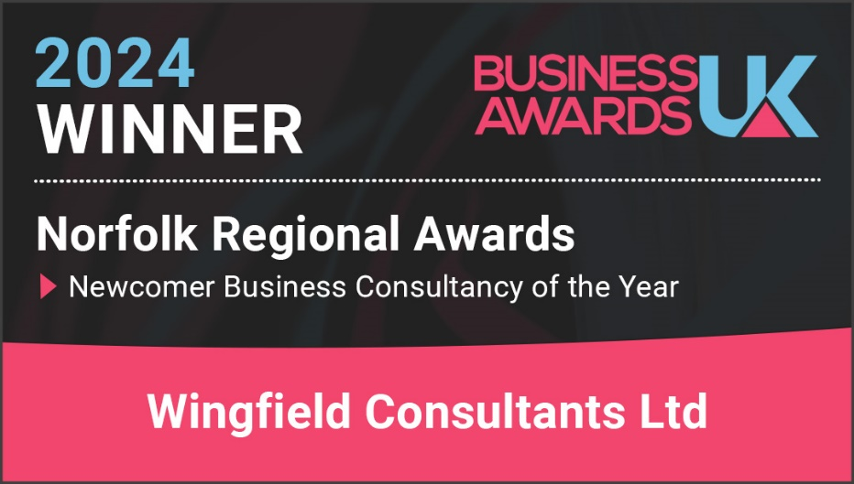

Wingfield Consultants have picked up further award WIN at the Business UK Awards for 2024.

The Business Awards UK team wrote to us a while back:

‘We will contact you soon if you were selected as a Winner - be sure to keep an eye out in your inbox - and good luck!

We also want to say thank you so much for participating in the awards, and congratulations once again on being Shortlisted. Most of all, thank you for supporting the UK business community!’

Simon Wingfield, Founder of Wingfield Consultants, said: ‘Well we did it! From being shortlisted to winning another national award! This recognition for the work we do in our home county of Norfolk shows how our business model and service we provide our clients resonates with awards judges.’
This is the EIGHTH award win, finalist or shortlist recognition for Wingfield Consultants in 2024. It follows the CorporateLiveWire Global Awards 2023-24 win for Business Consultancy of the Year – UK win, The National Mentoring Awards – Excellence in Mentoring Award win (for Simon Wingfield), the SME News Business Elite Awards win for Best Business Growth Solutions Consultancy (East of England), the StartUp Awards finalist for Business Consulting & Management StartUp of the Year (East of England), the British Business Awards finalist for Small Business of the Year, the Allica Bank Great British Entrepreneur Awards finalist for Scale-Up Entrepreneur of the Year (East of England), and a previous shortlist position for the above award.

Useful Links:

2024 Regional Business Awards Results - Business Awards UK (business-awards.uk)

End.

