Business Awards UK 2024 – Norfolk Regional Awards – CEO/Director of the Year (Winner – Simon Wingfield)
- News Release

Thursday 25th July 2024

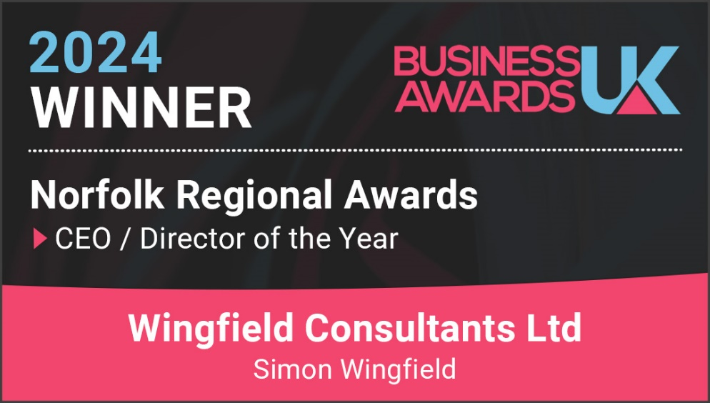

Wingfield Consultants have picked up another Business UK Awards for 2024 WIN!

The Business Awards UK team wrote to us a while back:

‘We will contact you soon if you were selected as a Winner - be sure to keep an eye out in your inbox - and good luck!’.

Simon Wingfield, Founder of Wingfield Consultants, said: ‘I’m very proud to have won an award for our consultancy, and especially pleased to be recognised for the work we do in my home county of Norfolk. This recognition for the work we do shows how our business model and service we provide our local clients resonates with awards judges.’
This is the NINTH award win, finalist or shortlist recognition for Wingfield Consultants in 2024. It follows the CorporateLiveWire Global Awards 2023-24 win for Business Consultancy of the Year – UK win, The National Mentoring Awards – Excellence in Mentoring Award win (for Simon Wingfield), the SME News Business Elite Awards win for Best Business Growth Solutions Consultancy (East of England), the StartUp Awards finalist for Business Consulting & Management StartUp of the Year (East of England), the British Business Awards finalist for Small Business of the Year, the Allica Bank Great British Entrepreneur Awards finalist for Scale-Up Entrepreneur of the Year (East of England), a previous shortlist position for the above award, and the Business Awards UK Newcomer Business Consultancy of the Year win (Norfolk).

Useful Links:

2024 Regional Business Awards Results - Business Awards UK (business-awards.uk)

End.

