The British Business Awards 2024 - Small Business of the Year (Finalist) - News Release

Thursday 11th July 2024

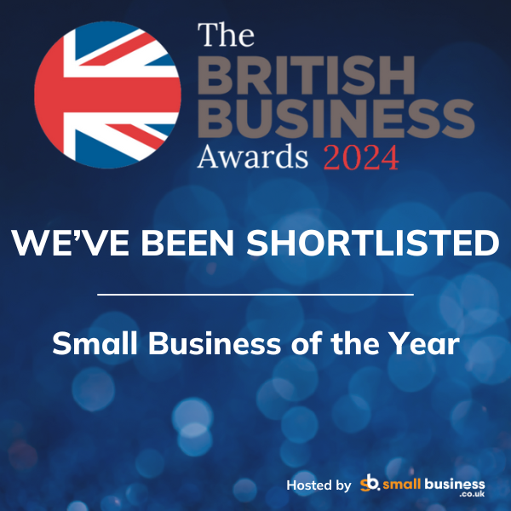
Wingfield Consultants have picked up further award shortlist at the British Business Awards for 2024.

Simon Wingfield, Founder of Wingfield Consultants, said: ‘We delighted overjoyed to be recognised by another big awards . This national recognition for Small Business of the Year is very exciting and demonstrates the progress we have made in supporting local businesses, communities, charities, and social enterprises in the last two years’.

This is the FIFTH award win, finalist or shortlist recognition for Wingfield Consultants in 2024. It follows the CorporateLiveWire Global Awards 2023-24 win for Business Consultancy of the Year – UK win, The National Mentoring Awards – Excellence in Mentoring Award win (for Simon Wingfield), the SME News Business Elite Awards win for Best Business Growth Solutions Consultancy (East of England), and the StartUp Awards finalist for Business Consulting & Management StartUp of the Year (East of England).

Useful Links:

British Business Awards 2024 – final shortlist revealed! - Small Business UK

End.

