The Allica Bank Great British Entrepreneur Awards 2024 - Scale-Up Entrepreneur of the Year East of England (Finalist) – News Release

Tuesday 16th July 2024
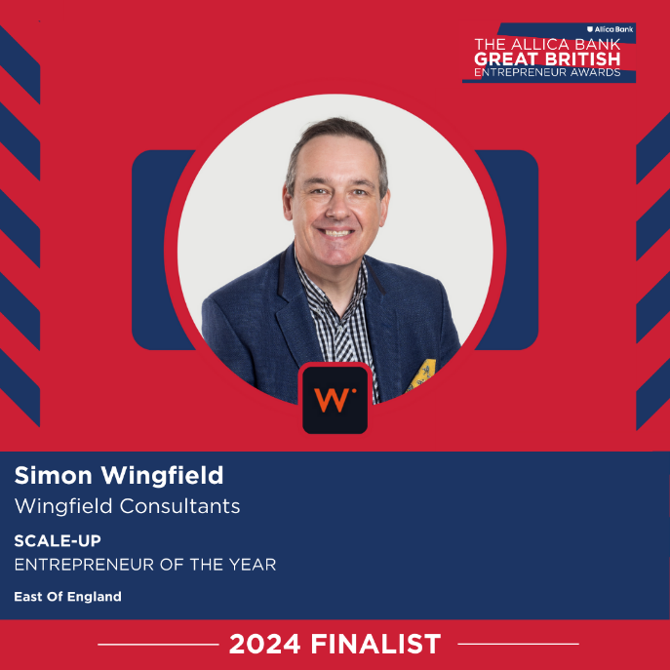
Wingfield Consultants have picked up further award shortlist at the British Business Awards for 2024.

Francesca, the Founder of the Great British Entrepreneur Awards, wrote to us:

‘I hope you’re still riding high from the excitement of being named a finalist for t being named a finalist for the 2024 Great British Entrepreneur Awards!
We’ve been loving reading all of the finalists social media posts and seeing the amazing press coverage businesses have been getting. Keep tagging us – it’s great to see and share your journey!’
Simon Wingfield, Founder of Wingfield Consultants, said: ‘Wow! Another award shortlist position in 2024! We are so please we are getting recognised for the work we do. This is testament to the support we provide to organisations (big and small) to help them grow and reach their potential.’
This is the SIXTH award win, finalist or shortlist recognition for Wingfield Consultants in 2024. It follows the CorporateLiveWire Global Awards 2023-24 win for Business Consultancy of the Year – UK win, The National Mentoring Awards – Excellence in Mentoring Award win (for Simon Wingfield), the SME News Business Elite Awards win for Best Business Growth Solutions Consultancy (East of England), the StartUp Awards finalist for Business Consulting & Management StartUp of the Year (East of England) and the British Business Awards finalist for Small Business of the Year.

Useful Links:

The Great British Entrepreneur Awards

End.

