StartUp Awards 2024 - Business Consulting & Management StartUp of the Year East of England (Finalist)
- News Release

Tuesday 9th July 2024
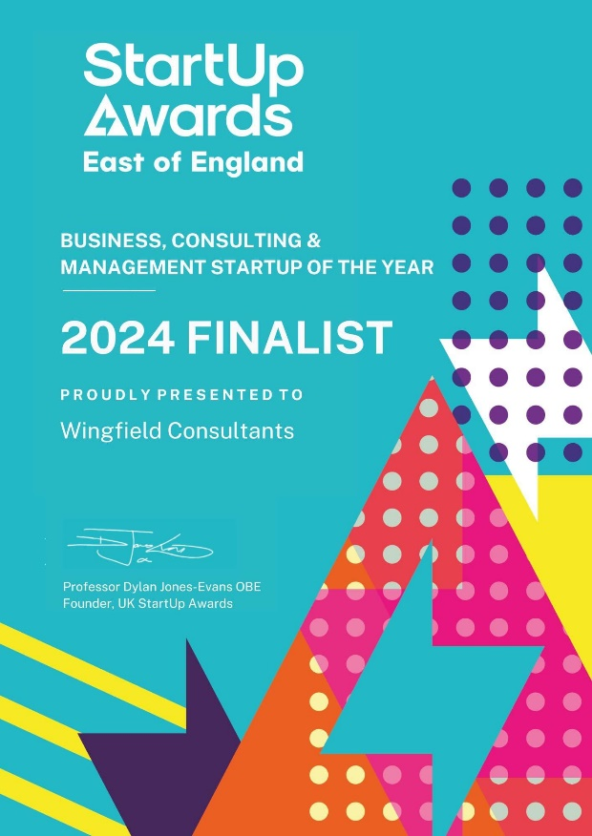
Wingfield Consultants have picked up another award with a finalist position at the StartUp Awards for 2024.

Professor Dylan Jones-Evans OBE, Founder of the UK StartUp Awards, wrote to us:

‘Thank you for being a part of this year's UK Startup Awards.

While you haven't advanced to the 2024 UK final, we truly appreciate your participation and thank you for your effort and dedication. This year, the competition was extremely tough, and your achievements in being shortlisted within your region speak volumes about your business.’

Simon Wingfield, Founder of Wingfield Consultants, said: ‘We overjoyed to be recognised by another prestigious awards organisation. This was due to our support for local organisations in the East of England region’.

This is the FOURTH award win, finalist or shortlist recognition for Wingfield Consultants in 2024. It follows the CorporateLiveWire Global Awards 2023-24 win for Business Consultancy of the Year – UK win, The National Mentoring Awards – Excellence in Mentoring Award win (for Simon Wingfield), and the SME News Business Elite Awards win for Best Business Growth Solutions Consultancy (East of England).

Useful Links:

Celebrating Innovation and Excellence | Startup Awards UK

End.

