Business Awards UK 2024 – Norfolk Business Awards (Shortlisted) – News Release

Thursday 18th July 2024
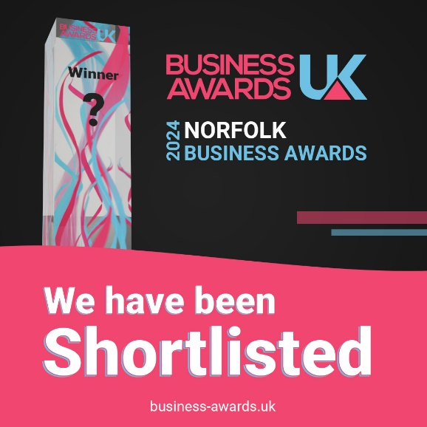
Wingfield Consultants have picked up further award shortlist at the Business UK Awards for 2024.

The Business Awards UK team wrote to us:

‘We will contact you soon if you were selected as a Winner - be sure to keep an eye out in your inbox - and good luck!

We also want to say thank you so much for participating in the awards, and congratulations once again on being Shortlisted. Most of all, thank you for supporting the UK business community!’

Simon Wingfield, Founder of Wingfield Consultants, said: ‘These award recognitions keep rolling in this year! Our business model of 80% paying clients and 20% pro bono supporting local communities, charities, and businesses is one we have stuck to. Why? Because ‘People don’t buy what you do; they buy why you do it. And what you do simply proves what you believe’ (Simon Sinek, Start with Why: How Great Leaders Inspire Everyone to Take Action’). These recognitions show that our model resonates.’
This is the SEVENTH award win, finalist or shortlist recognition for Wingfield Consultants in 2024. It follows the CorporateLiveWire Global Awards 2023-24 win for Business Consultancy of the Year – UK win, The National Mentoring Awards – Excellence in Mentoring Award win (for Simon Wingfield), the SME News Business Elite Awards win for Best Business Growth Solutions Consultancy (East of England), the StartUp Awards finalist for Business Consulting & Management StartUp of the Year (East of England), the British Business Awards finalist for Small Business of the Year, and the Allica Bank Great British Entrepreneur Awards finalist for Scale-Up Entrepreneur of the Year (East of England).

Useful Links:

2024 Regional Business Awards Shortlists - Business Awards UK (business-awards.uk)

End.

