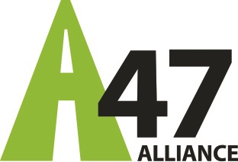

Company name: ……………………………………………………

Location: ……………………………………………………

Annual turnover: ……………………………………………………

Total staff: ……………………………………………………

Sector: ………………………………………………………

Multiple choice testimonial

“Our business supports the A47 Alliance’s call for A47 dualling because a fully dualled A47 would help our business to:

[ Please delete any statements below that do not apply to your business ]

- Be more profitable by reducing our transport-related costs

- Help us to attract more national and international business by improving links between ports and airports and the national trunk road network

- Attract more customers by improving our accessibility

- Accelerate growth and expansion

- Reduce inefficiencies due to delays and unreliable journey times

- Gain and retain highly skilled staff by reducing time spent on their commute

- Invest with confidence in the region

Free text testimonial
[ Please use this space if you would like to write more on why your organisation supports the A47 Alliance’s ask. This could be used on our website and social media ]

“[Add organisation name] supports the A47 Alliance’s ask for A47 dualling because ……………………………………………………………………………………………………………………………………………………………………………………………………………………………………………………………………………………………………………….………………………………………………………………………………”

